**Assignment no 1**

//Draw a truth table 5 times

//write a program for all relational operators

(<,>,>=,<=,==,!=)

Program 1:

Code:

#include<stdio.h>

void main()

{

int a,b,c;

a=13;

b=29;

c=a<b;

printf("%d=%d<%d",c,a,b);

}

Output:

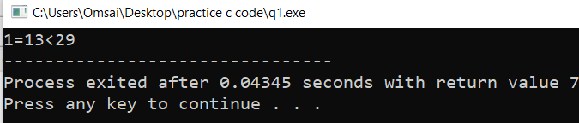

Program 2:

Code:

#include<stdio.h>

void main()

{

int a,b,c;

a=23;

b=13;

c=a>b;

printf("%d=%d>%d",c,a,b);

}

Output:

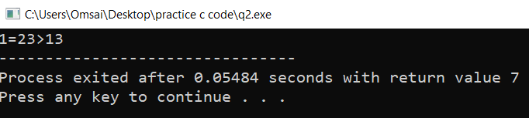

Program 3:

Code:

#include<stdio.h>

void main()

{

int a,b,c;

a=23;

b=13;

c=b<=a;

printf("%d=%d<=%d\n",c,b,a);

c=a<=b;

printf("%d=%d<=%d",c,a,b);

}

Output:

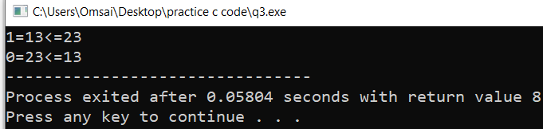

Program 4:

Code:

#include<stdio.h>

void main()

{

int a,b,c;

a=25;

b=15;

c=b>=a;

printf("%d=%d>=%d\n",c,b,a);

c=a>=b;

printf("%d=%d>=%d",c,a,b);

}

Output:

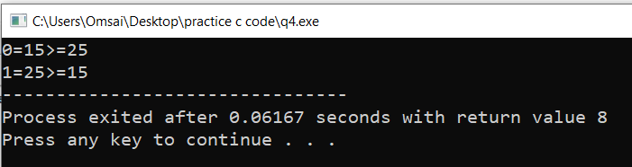

Program 5:

#include<stdio.h>

void main()

{

int a,b,c,d;

a=25;

b=15;

c=25;

d=a==b;

printf("%d=%d==%d\n",d,a,b);

d=a==c;

printf("%d=%d==%d",d,a,c);

}

Output:

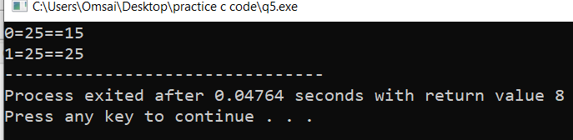

Program 6:

Code:

#include<stdio.h>

void main()

{

int a,b,c,d;

a=25;

b=15;

c=25;

d=a!=b;

printf("%d=%d!=%d\n",d,a,b);

d=a!=c;

printf("%d=%d!=%d",d,a,c);

}

Output:

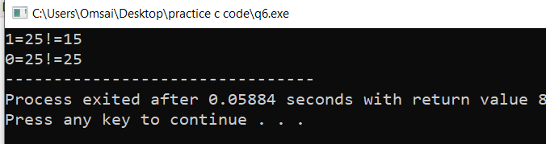

//write a program for logical operators

//logical operator (&&)

Code:

#include<stdio.h>

void main()

{

int a,b,c,d;

a=12,b=0,c=13;

d=a&&b;

printf("%d=%d&&%d\n",d,a,b);

d=a&&c;

printf("%d=%d&&%d\n",d,a,c);

}

Output:

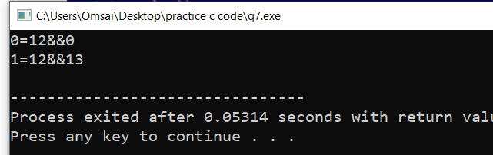

//logical operator (||)

Code:

#include<stdio.h>

void main()

{

int a,b,c,d,x;

a=12,b=0,c=13,x=0;

d=a||b;

printf("%d=%d||%d\n",d,a,b);

d=a||c;

printf("%d=%d||%d\n",d,a,c);

d=b||x;

printf("%d=%d||%d\n",d,b,x);

}

Output:

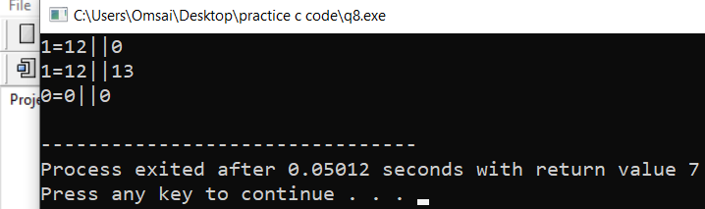

// WAP for area and perimeter of circle

Code:

#include<stdio.h>

void main()

{

float r,area,perimeter;

printf("radius of circle:");

scanf("%f",&r);

area= 3.14*r*r;

perimeter= 2*3.14*r;

printf("Area of circle is %f\n",area);

printf("Perimeter of circle is %f",perimeter);

}

Output:

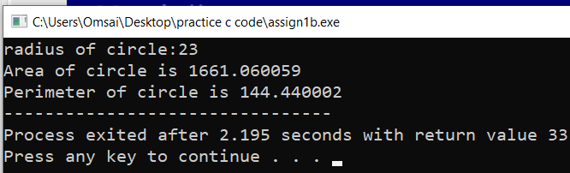

// WAP for area and perimeter of rectangle

Code:

#include<stdio.h>

void main()

{

int l=12,b=45,area,perimeter;

area= l*b;

perimeter= 2*l+2*b;

printf("Area of ractangle is %d\n",area);

printf("Perimeter of rectangle is %d",perimeter);

}

Output:

